**Assignment Two**

**Comp 3910**

Ng, Kwok Chu Anthony (A00914468)

Shon, She Jong (A00927035)

Date: Nov 18th, 2015

**Table of Content**

1. Pages and Sub-pages
2. Screenshots of pages and sub-pages
3. Requirements and functions
4. Test plan
5. Class diagram
6. Build and Deploy instructions

**Pages and Sub-pages**

1. Login page
2. Logout page (same as login)
3. Non-manager landing page
   1. View timesheet
   2. Create timesheet
4. Manager landing page
   1. Create user page
   2. View users page
   3. View timesheet
   4. Create timesheet

**Screenshots**

1. Login page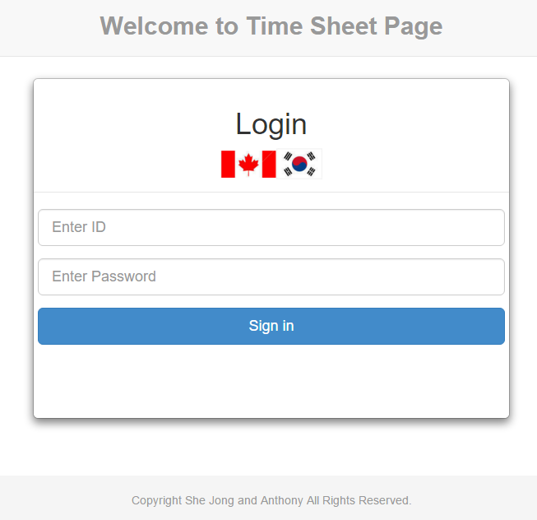
2. Non-manager landing page

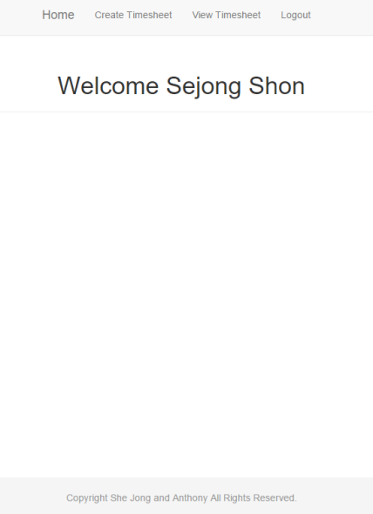

1. Manager landing page

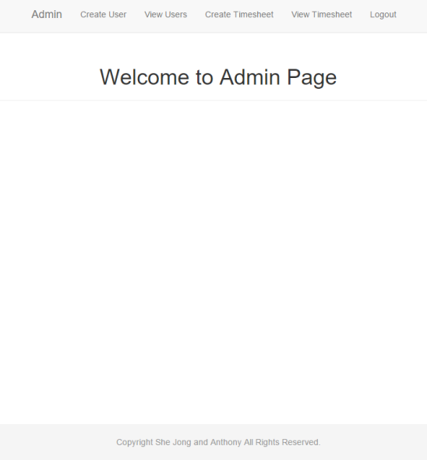

1. Create user page

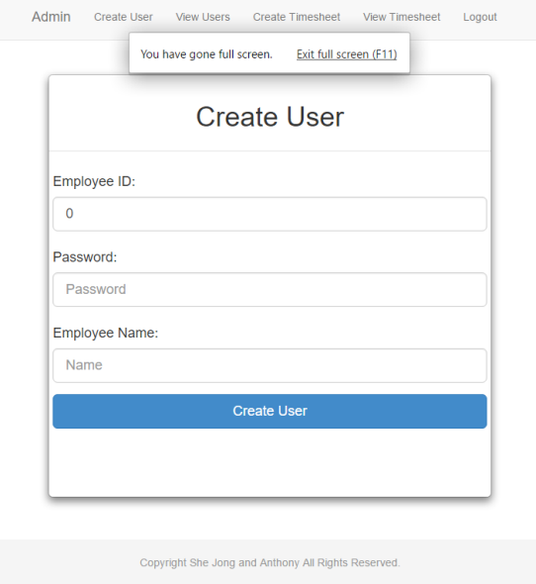

1. View users page

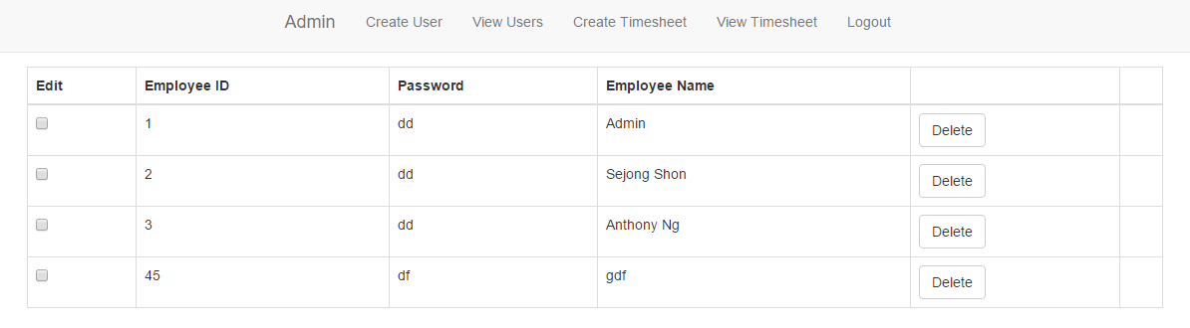

1. Create timesheet

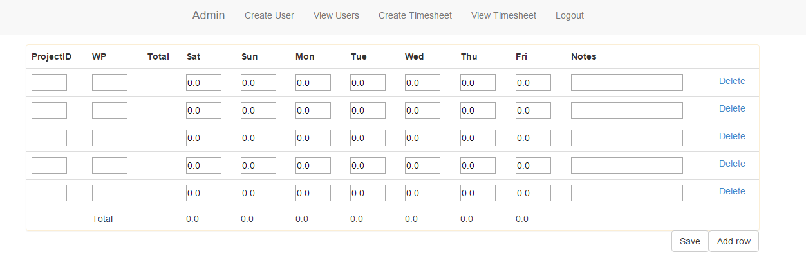

1. View timesheet

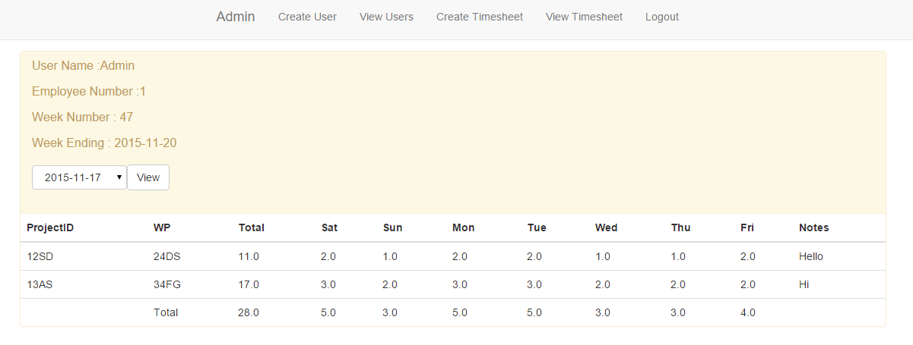

**Requirements and functions**

1. Login page
   1. Allows user to input user-name and password
   2. With the correct credentials user can log into their accounts
   3. User can choose localization(Korean or English)
2. Logout page
   1. Logs out of the system, allows other users to login
3. Non-manager landing page
   1. The welcoming page for a non-manager
   2. Includes a list of action that they can choose from
      * Which includes the following options of actions:
        1. View timesheet
        2. Create timesheet
4. View timesheet
   1. Views a past timetable
      * However, it is not editable
5. Create timesheet
   1. At the moment of creation, a timesheet should have 5 empty rows
   2. There should be a button to add rows
   3. Time inputs are input in hours (e.g. 0.0 – 24.0 hours)
   4. Headers files are fill in automatically once a timetable is created
   5. Week number and week-ending is default to the current week
6. Manager landing page
   1. The welcoming page for a manager
      * Which includes the following options of actions:
        1. Create user page
        2. View users page
        3. View timesheet
        4. Create timesheet
7. Create user page
   1. A page for only manager
   2. Allows the user to create new users with their profile and information
8. View users page
   1. A page for only manager
   2. Allows the user to edit existing user profiles and information

**Test plan**

1. Login page
   * Users will enter a correct combination of password and user-name
   * User can choose localization(Korean or English)
2. Logout page
   * User can logout of their account by pressing the logout button the top of the page
   * After pressing the logout button it returns to the login page
3. Non-manager landing page
   * A list of options will be available to click on at the top of the page
   * Each option should correctly lead to corresponding pages
   * A welcome message will appear with the user’s name on it
4. Manager landing page
   * A list of options will be available to click on at the top of the page
   * Each option should correctly lead to corresponding pages
   * A welcome message will appear on the landing page
   * It will have two more buttons in the option field which are create a user and view user page
5. View timesheet
   * This page should show the exact data on the timetable last time it was edited, however it should not allow further edits
6. Create timesheet
   * When a new timesheet is created five rows will appear
   * It will be defaulted as current week
   * Clicking on the add row button will add a row to the table
   * Time entered during the week must be in the unit of hour from 0.0 to 24.0, it may be integer or with one decimal place
   * WP (Working Project) must have alphabetical value combined with numerical value
   * Total number of hours should appear before the column of the day of the week column
     + The calculation is done automatically, however it is only done when the user clicks the save button
7. Create user page
   * This page allows a manager to create a new user by filling out the following fields:
     + Name field
     + User-name field
     + Password field
8. View users page
   * This page will show all the users in a list with all their information beside their name. The manager can click on a check box with a title called edit, make changes.
   * Changes include all information including password

**Test Results:**

1. Login page
   * Users will enter a correct combination of password and user-name (TESTED)
   * User can choose localization(Korean or English) (TESTED)
2. Logout page
   * User can logout of their account by pressing the logout button the top of the page (TESTED)
   * After pressing the logout button it returns to the login page (TESTED)
3. Non-manager landing page
   * A list of options will be available to click on at the top of the page (TESTED)
   * Each option should correctly lead to corresponding pages (TESTED)
   * A welcome message will appear with the user’s name on it (TESTED)
4. Manager landing page
   * A list of options will be available to click on at the top of the page (TESTED)
   * Each option should correctly lead to corresponding pages (TESTED)
   * A welcome message will appear on the landing page (TESTED)
   * It will have two more buttons in the option field which create a user and view users page (TESTED)
5. View timesheet
   * This page should show the exact data on the timetable last time it was edited, however it should not allow further edits (TESTED)
6. Create timesheet
   * When a new timesheet is created five rows will appear (TESTED)
   * It will be defaulted as current week (TESTED)
   * Clicking on the add row button will add a row to the table (TESTED)
   * Time entered during the week must be in the unit of hour from 0.0 to 24.0, it may be integer or with one decimal place (TESTED)
   * WP (Working Project) must have alphabetical value combined with numerical value (TESTED)
   * Combination of project number and working project field must be unique (Didn't implement this)
   * Total number of hours should appear before the column of the day of the week column (TESTED)
     + The calculation is done automatically, however it is only done when the user clicks the save button (TESTED)
7. Create user page
   * This page allows a manager to create a new user by filling out the following fields:
     + Name field (TESTED)
     + User-name field (TESTED)
     + Password field (TESTED)
8. View users page
   * This page will show all the users in a list with all their information beside their name. The manager can click on a check box with a title called edit, make changes. (TESTED)
   * Changes include all information including password (TESTED)

**Class diagram**

(Attached inside the folder since it is too big to place inside a word document)

**Build and Deploy instructions**

*Configurations*

* Java development Kit 8
* Eclipse Java EE IDE for Web Developers.
  + Version: Mars Release (4.5.0)
* Wildfly 9.1 and JBOSS_HOME define
* MYSQL 5.6

*Importing*

File->import projects from folder -> and Import successfully

**Extra Bonus Marks**

1) Implemented additional language. Korean in our case.

2) We used Bootstrap to enhance our UI features

**Etc**

* Employee ID is a user name(numeric)

Admin account

Id: 1

Password: admin

User account

Id: 2

Password: shon